**DEPARTMENT PART**

**Head Clerk**

“**Verification Application and Preparation License by Head Clerk”**

**Step 1:**

Login as “**Head Clerk**” in Service plus web portal.

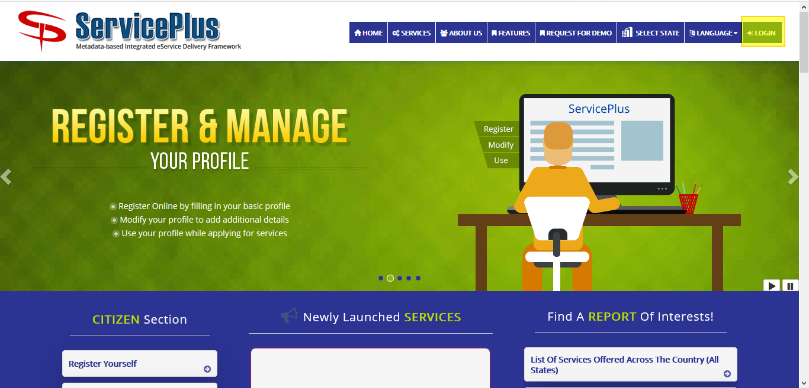

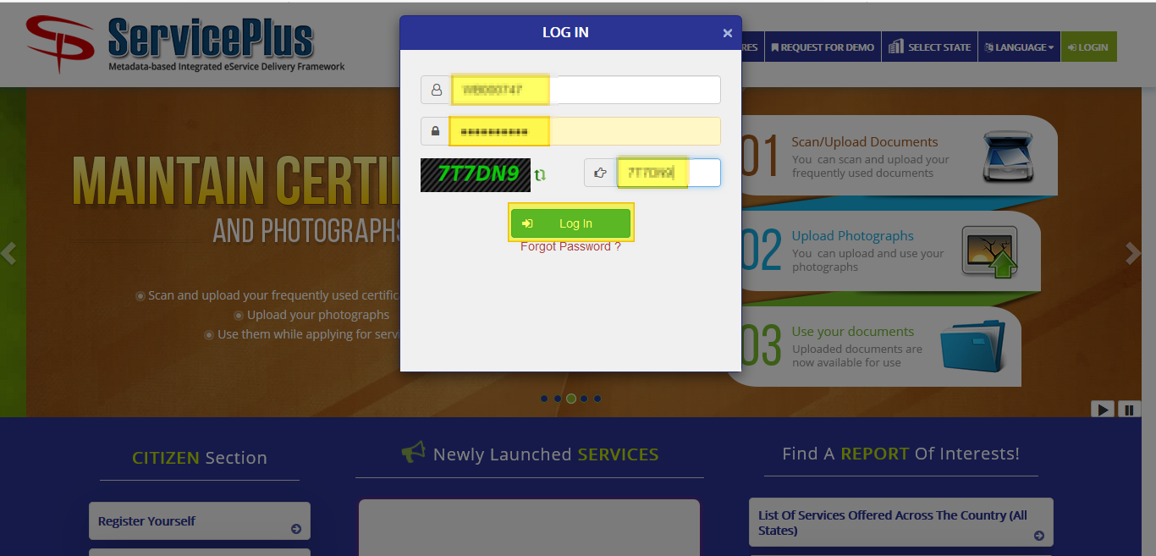

**Step 2:**

Now Go to **“Message Box”** and select **“Inbox”**.

In Inbox select the service **“Application for License Renewal of Flat in Bidhannagar Municipal Corporation Area”** and select the task **“Verification Application and License Preparation by Head Clerk”** and select **“Get Data”.**

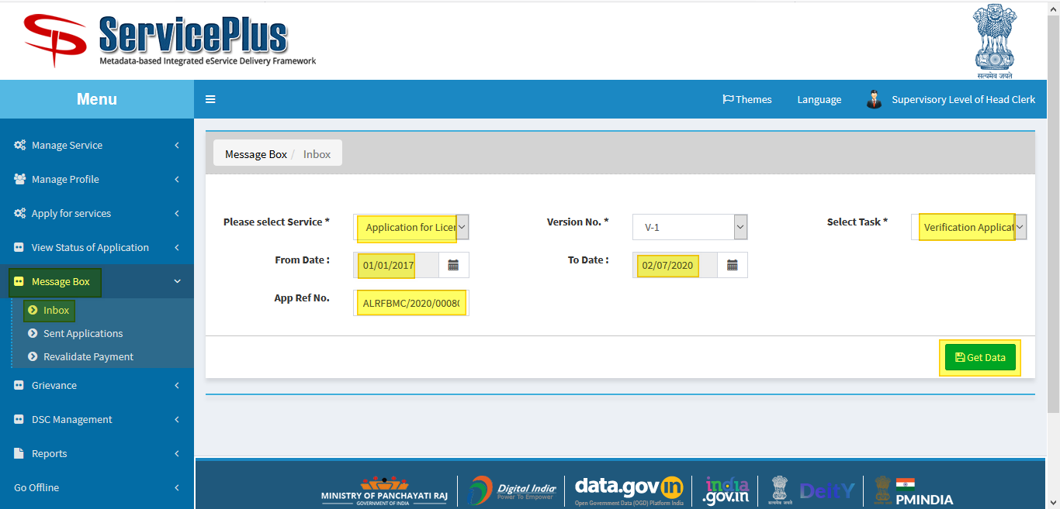

**Step 3:**

Select **“Pull”/ “Take Action”** to take action.

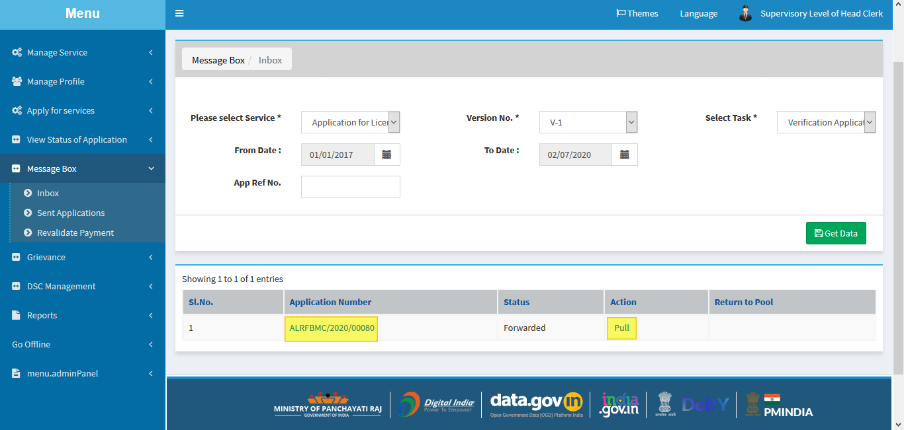

**Step 4:**

Select **“View Processing History”** to see the history of the application.

Action of the form can be taken by **Estate Officer** by taking action in three steps to **forward to**

* **Application Submission Shortfall**
* **Issuance License by Estate Officer cum Joint Secretary**.
* **Recommendation for Rejection**

If selected “**Issuance License by Estate Officer cum Joint Secretary**” then the new license section should be filled up and submit button clicked.

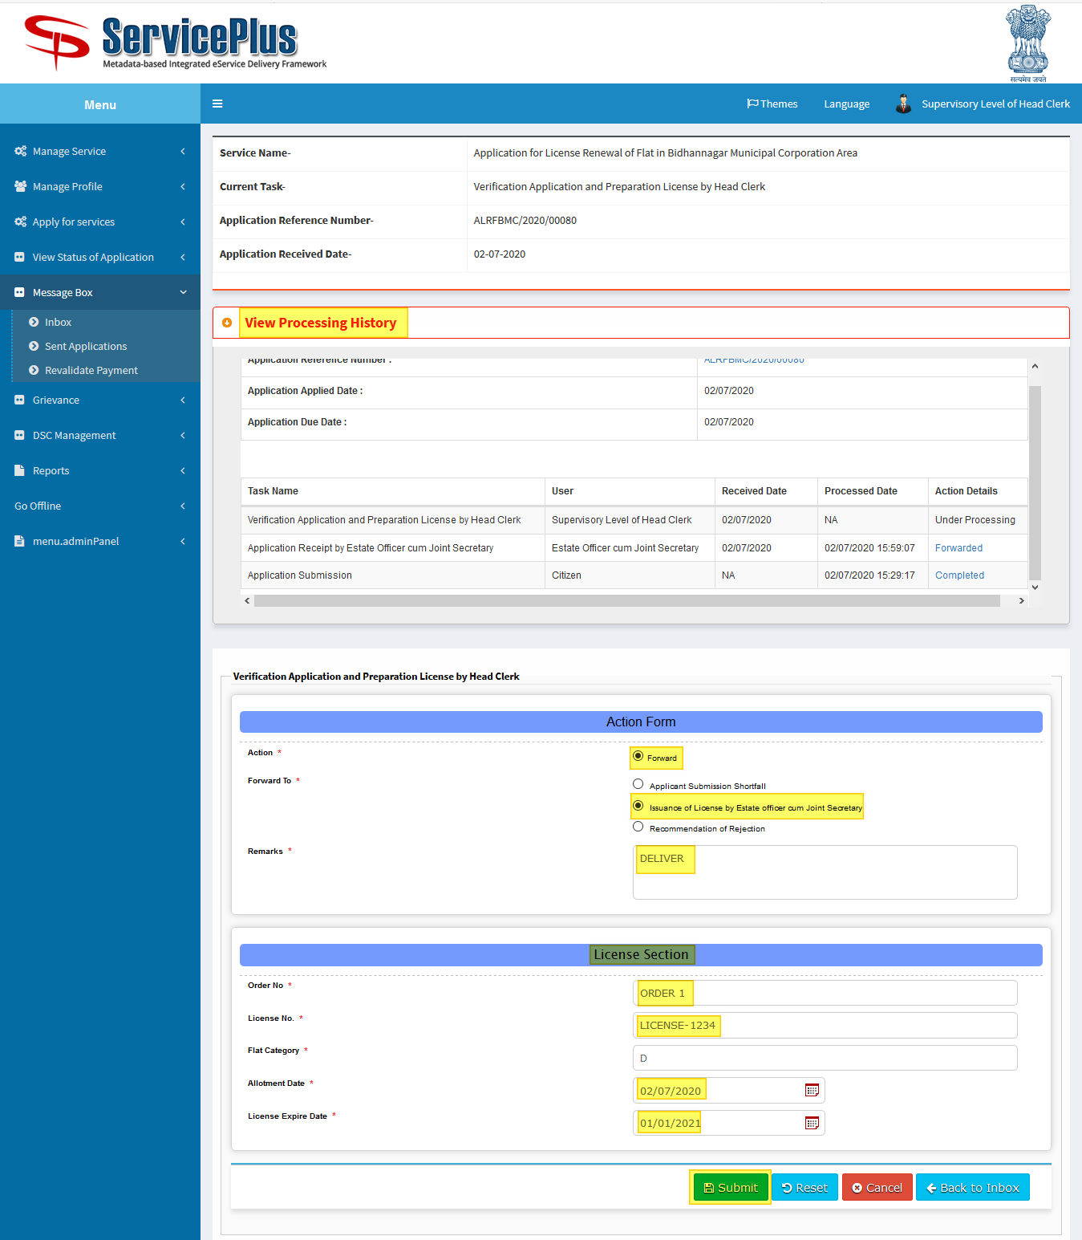

**Step 5:**

Now download the document by clicking the file icon.

And submit it.

An example certificate is attached.

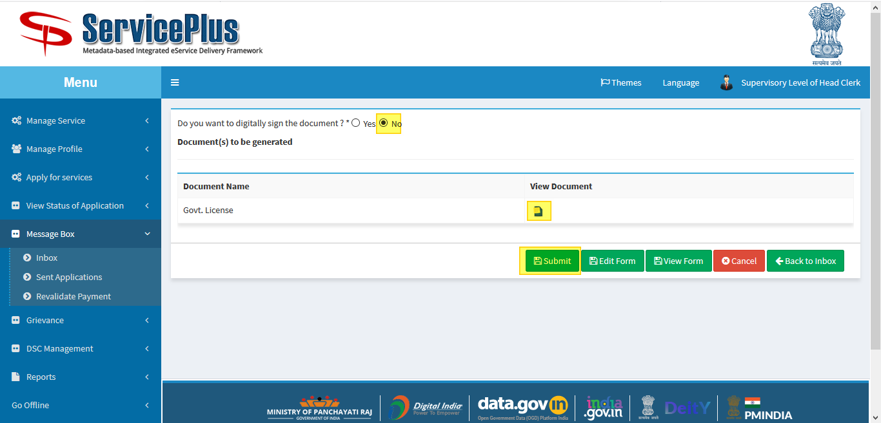

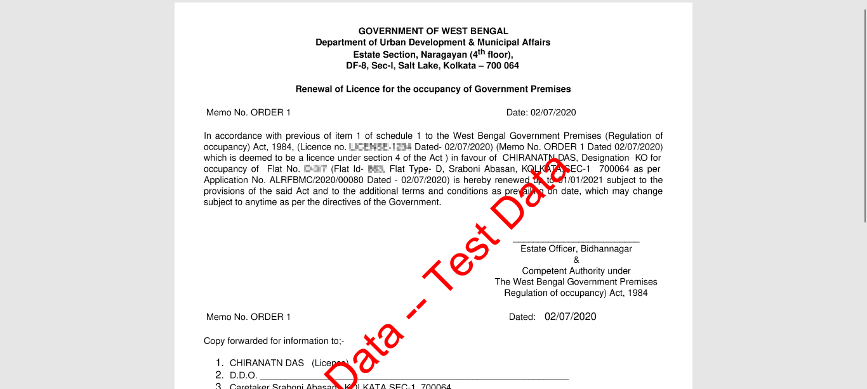

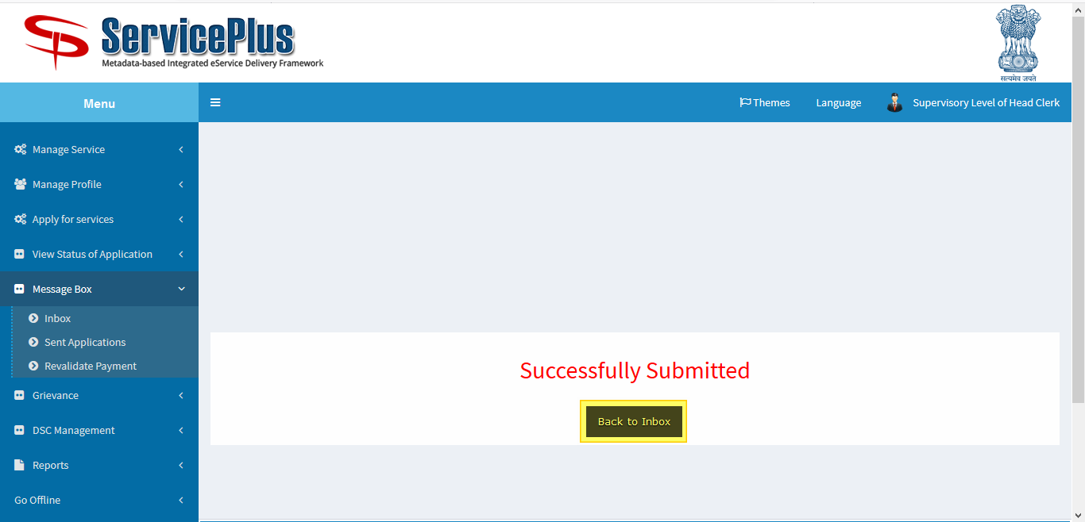

**SHORTFALL SELECTED**

**Head Clerk**

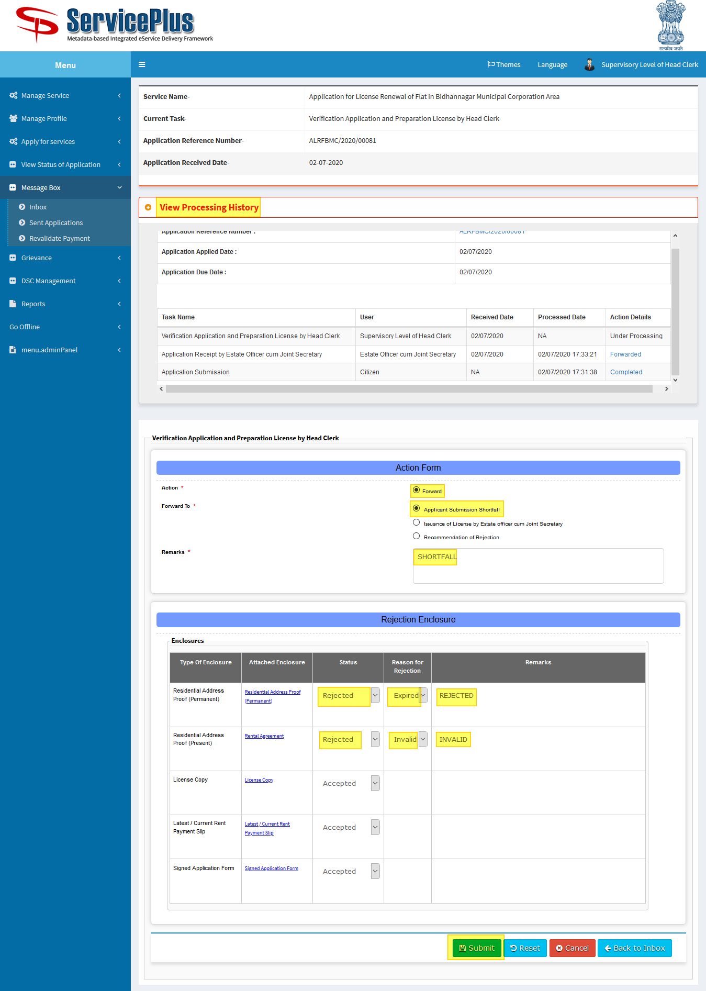

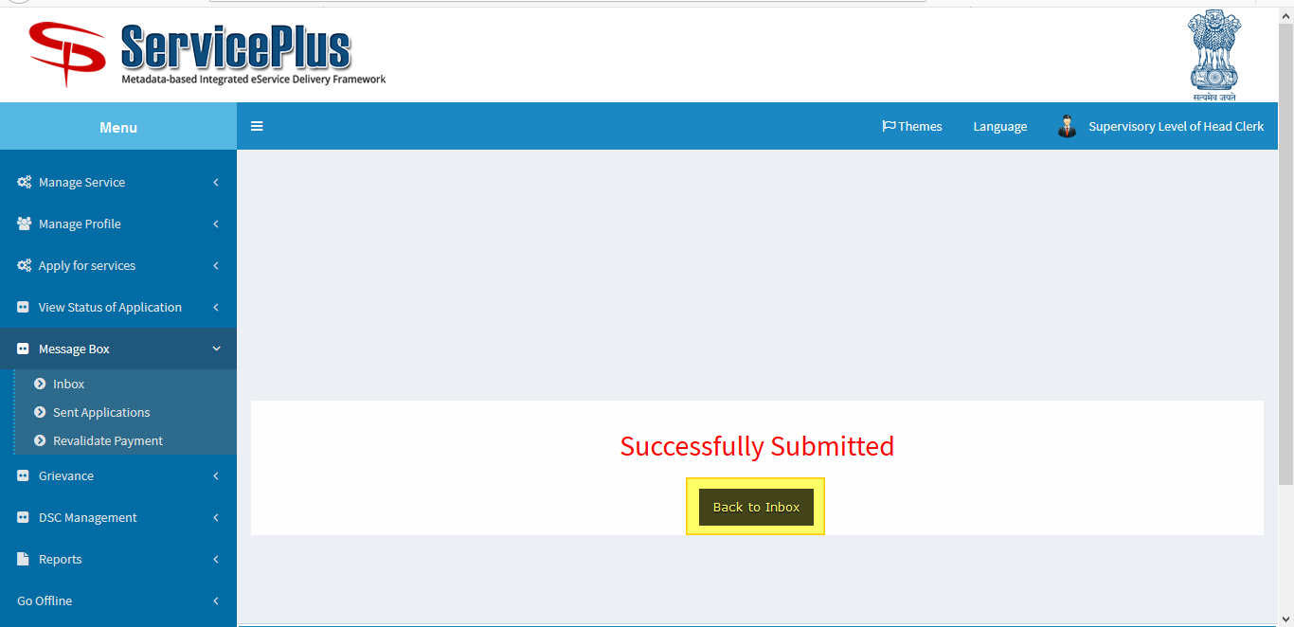

**RECOMMENDATION FOR REJECTION**

**Head Clerk**

